BOOK UP
Analysis Model

Submitted to:

Asst. Prof. Ma. Rowena C. Solamo
Faculty Member
Department of Computer Science
College of Engineering
University of the Philippines, Diliman

Submitted by:
AGNES, Karen Margaret D.
AYCOCHO, Matthew M.

In partial fulfillment of Academic Requirements
for the course
CS 191 Software Engineering I
of the
1st Semester, AY 2016-2017
Revision Control

History Revision:
Revision Date | Person Responsible | Version  Number | Modification
10/20/16 | Karen Agnes | 1.0 | Initial Document; Made the class diagram
10/20/16 | Matthew Aycocho | 1.1 | Added boundary and control classes for view trade matches; Added descriptions

Purpose:

The document serves as a requirement in the course CS 191 Software Engineering I.

Audience:

The document attends as requirement compliance to Prof. Ma. Rowena C. Solamo.
System Name: Book Trading System

Description: Book Up is a mobile application used for easily trading books with other people. It is
designed to match a user with other users by registering books the user wants to
trade, searching for available books the user is interested in, and finding a compatible
partner who wants make the book trade. It also includes scheduling the trade meet up.

Class Diagram:

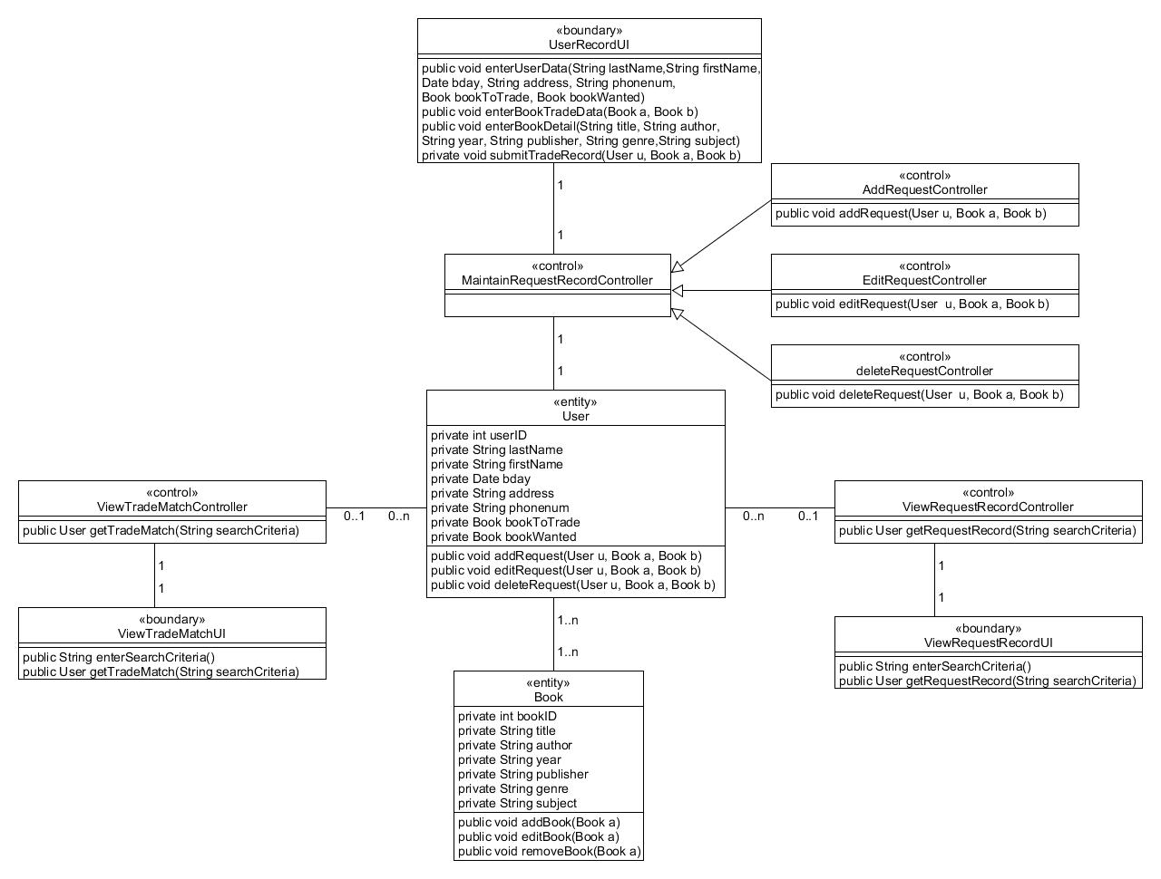

Boundary Classes:

Class Name | Description
UserRecordUI | This is used for inputting the required information for a trade request
ViewRequestRecordUI | This is used for viewing user’s request record following the search criteria
ViewTradeMatchUI | This is used for viewing user’s trade matches following the search criteria

Control Classes:

Class Name | Description
MaintainRequestRecordController | This is used for managing the trade request record
AddRequestController | This is used for adding a trade request
EditRequestController | This is used for editing a trade request
DeleteRequestController | This is used for deleting a trade request
ViewRequestRecordController | This is used for searching for trade requests
ViewTradeMatchController | This is used for searching for trade matches

Entity Classes:

Class Name | Description
User | This is used for storing information about a trade request
Book | This is used for storing information about a book

